STUDIA UNIVERSITATIS BABEȘ-BOLYAI
Engineering 68(1) 2023 DOI:
Title of the paper (Times new roman TNR, 12, Bold). Let 12pt after the title.
Insert here the name(s) of the author(s) in format of First Names and Surname of the Authors (without titles and addresses)
John Smith, Nicolae Georgescu* (TNR, 11, Normal) left 0.9 cm, right 0.9 cm.
Let 12pt after the author names
Abstract. Insert here the text of abstract. Text of the abstract no more than 12 lines, but minimum 5 lines. (TNR, 11, Italic). Abstract and titles are indented from both sides with 0,9 cm. Let 12pt after the abstract.
Keywords: insert, 3 up to 5, keywords (Let 12pt after the aabstract.)
1. Introduction (TNR, 11, Bold) Let 12 pt after the title.
Paper margins: Top & Bottom 5.5 cm, Left & Right 4 cm, Paper Size A4, minimum 6 pages and maximum 14 pages.
Tabulator 0,7cm. Text of the section. (TNR, 11, Normal) Text of the section. Text of the section. Text of the section. Text of the section. Text of the section.
Use Equation Editor for equations. Do not insert the Equations in tables. Let 6pt before and after the row on which the Equation is. An example is given below:
(1)
and the next row starts without tabulator if the phrase continues it, just as shown here. If not a new paragraph starts, use tabulator.
Text of the section. Text of the section. Text of the section. Text of the section. Text of the section. Text of the section. (TNR, 11, Normal)
This is an example of figure import. To get figures best printed, please make them ready in 600 dpi before importing it into MS-Word.

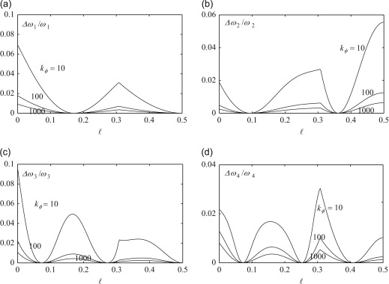
Figure 1. The text of figure caption. (TNR, 11, Normal)

Text of the section. Text of the section. Text of the section. Text of the section. To create text of the section, use style "Body". (TNR, 11, Normal)
Text width is set to 13 cm and text height to 19 cm.
2. Analysis. Title of the second section may be longer than one row but just leave it like this (take 12pt before and 12pt after the section’s title)
Text of the section. Text of the section. Text of the section. Text of the section. Text of the section. Text of the section. Text of the section. Text of the section. Text of the section. Text of the section. Text of the section. Text of the section. Text of the section. Text of the section. (TNR, 11, Normal)

2.1. Title of the subsection (TNR, 11, Bold) Let 6pt after the subsection’s title.
Text of the section. Text of the section. Text of the section. Text of the section. Text of the section. Text of the section. Text of the section. Text of the section. Text of the section. Text of the section. Text of the section. Text of the section. Text of the section. Text of the section. (TNR, 11, Normal)
3. Examples. The paper can include all the necessary sections (take 12pt before and 12pt after the section’s title)
Text of the section. Text of the section. Text of the section. Text of the section. Text of the section. Text of the section. Text of the section. Text of the section. Text of the section. Text of the section. Text of the section. Text of the section. Text of the section. Text of the section. (TNR, 11, Normal)
Text of the section. Text of the section. Text of the section. Text of the section. Text of the section. Text of the section. Text of the section. Text of the section. Text of the section. Text of the section. Text of the section. Text of the section. Text of the section. Text of the section. (TNR, 11, Normal)

Table 1. Text (TNR, 11, Normal, after 6 pct)
Text | Text | Text | Text | Text
Text (TNR, 10, Normal)

Text of the section. Text of the section. Text of the section. Text of the section. Text of the section. Text of the section. Text of the section. Text of the section. Text of the section. Text of the section. Text of the section. Text of the section. (TNR, 11, Normal)
4. Conclusion (TNR, 11, Bold) before and after 12 pct
Text of the section. Text of the section. Text of the section. Text of the section. Text of the section. Text of the section. Text of the section. Text of the section. Text of the section. Text of the section. Text of the section. Text of the section. Text of the section. Text of the section. Text of the section. Text of the section. (TNR, 11, Normal)
Acknowledgment. This work was supported by a grant of the Romanian Ministry of Research and Innovation, CCCDI-UEFISCDI, project number ..., within PNCDI III. (Example)
References (TNR, 11, Bold) before and after 12 pct
Maxim 25 references, avoid unnecessary citation and self-citation (maximum 5 auto citation).
(Example for journal articles)
1 Vasilakis O., Biro P., Title of the Paper, International Journal of Science and Technology, 10(3), 2017, pp. XX-XX. (11pt TNR - journal title italic)
(Example for books)
2 Quonan O., Title of the Book, Publishing House, 2010. (11pt Times New Roman book title italic)

(Example for conference paper)
3 Grundorat S., Basilly O., Quonan O., Title of the Paper, 21st International Conference on Science and Technology, Mar. 23, 2012, Chicago, U.S., pp. XX-XX. (11pt Times New Roman)
(Example for Internet sources)
4 Criogenics basics and applications, http://www.cevgroup.org/cryogenics-basics-applications/ (downloaded at June 23rd, 2019).
5 Ionescu I., Popescu V., Title of the Paper, Analele Universitatii „Eftimie Murgu“ Resita, Fascicula de Inginerie, 21(1), 2014, pp. XX-XX.
Addresses: (italic, space before and after 12 pt.)
- Prof. Dr. Eng. John Smith, Affiliation, address,
j.smith@yahoo.com
- Prof. Dr. Eng. Nicolae Georgescu, Babeș-Bolyai University, Faculty of Engineering, Piaţa Traian Vuia, nr. 1-4, 320085, Reşiţa, Romania
nicolae.georgescu@ubbcluj.ro
(*corresponding author)
- These paragraphs were created with style "Address", bullets turned on by default. (TNR, 11, Normal) left 0.3 cm, right 0.9 cm

